SIMATS ENGINEERING (SAVEETHA SCHOOL OF ENGINEERING)
Department of Artificial Intelligence and Machine Learning

ASSESSMENT 1 – Design and Develop Model (5 QUESTIONS)

Course Code: | MLA0407 | Course Title: | Deep Learning  Assessment 1: Design and  Develop Model  (5 Questions × 10 Marks)
CO Assessed: | CO3 | Assessment:
Weightage: | 35% of CIA | Total Marks:
CO1 Statement: | Apply the fundamental concepts of machine learning and neural networks to design and analyze learning algorithms using perceptrons, multilayer perceptrons, forward propagation, backpropagation, gradient descent optimization techniques, and Maximum Likelihood Estimation for solving real-world problems.
Student Name: | I. Leela Sravan Kumar | Reg. No.: | 192425272  27.08.2026
Section / Batch: | AIML (2024) | Date:

Code of Conduct
I I. Leela Sravan Kumar (192425272) (NAME/ REG NO) certify that this submission is my original work and
that I have adhered to the guidelines specified for this assessment. I understand that any violation of academic integrity rules will result in disciplinary action. Signature of the Student:

QUESTIONS: 5 Total Marks: 50

Annexure A

Design and Develop Model

- Transfer Learning for Image Classification
Design and develop an image classification model using Transfer Learning with DenseNet. Use a pretrained DenseNet model as a feature extractor, add a custom classification layer, and evaluate the model's performance on a suitable dataset.

- Fine-Tuning a Pre-Trained Model
Develop an image classification system using a pre-trained deep learning model and apply fine- tuning. Compare the performance of the model before and after fine-tuning and analyze the impact of unfreezing different layers.

- Feature Extraction-Based Model
Design and develop a deep learning model using a pre-trained CNN as a feature extractor for a realworld classification problem. Extract deep features, train a custom classifier, and evaluate the effectiveness of transfer learning.

- Medical Image Classification
Design and develop a transfer learning-based model for classifying medical images, such as pneumonia detection, skin disease classification, or brain tumor detection. Use a pre-trained model and evaluate its accuracy and other performance metrics.

- RNN for Text Classification
Design and develop a Recurrent Neural Network (RNN) model for text classification. Use an appropriate dataset to classify text into different categories and analyze how sequential information is processed by the network.

- Sentiment Analysis Using LSTM
Develop a sentiment analysis system using Long Short-Term Memory (LSTM). Classify user reviews or social media posts as positive, negative, or neutral and compare the results with a traditional RNN model.

- Bidirectional RNN for Sequence Classification
Design and develop a Bidirectional RNN (BiRNN) model for sequence classification. Compare its performance with a standard RNN and explain how processing information in both forward and backward directions improves the model.

- Next-Word Prediction Using LSTM
Develop an LSTM-based next-word prediction system. Train the model on a suitable text corpus and demonstrate how the model learns sequential patterns and predicts the most probable next word.

- Encoder–Decoder Sequence-to-Sequence Model
Design and develop an Encoder–Decoder-based Sequence-to-Sequence model for an application such as text summarization, machine translation, or question-answer generation. Explain the role of the encoder and decoder in processing sequences.

- Comparative Deep Learning Model
Design and develop multiple deep learning models for the same problem using Transfer Learning, RNN, BiRNN, or LSTM techniques. Compare their architectures and performance using appropriate evaluation metrics, and justify which model is most suitable for the selected application.

QUESTION 1 – TRANSFER LEARNING FOR IMAGE CLASSIFICATION

Problem
Design and develop an image classification model using Transfer Learning with DenseNet. Use a pre-trained DenseNet model as a feature extractor, add a custom classification layer, and evaluate the model.

Answer
Transfer Learning uses a model that has already been trained on a large dataset and adapts it to a new classification problem.
For this problem, DenseNet121 can be used as the pre-trained model. A suitable dataset such as CIFAR-10 can be used.

Architecture
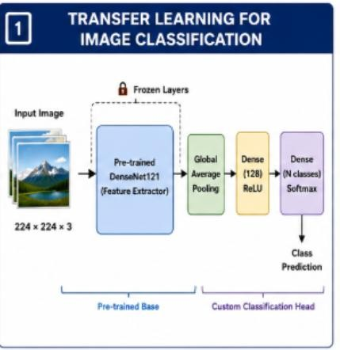

Steps
- Load the image dataset.
- Resize images according to DenseNet input requirements.
- Normalize pixel values.
- Load pre-trained DenseNet121 without its original classifier.
- Freeze the DenseNet layers.
- Add Global Average Pooling.
- Add a Dense classification layer.
- Use Softmax for multi-class classification.
- Train only the newly added layers.
- Evaluate the model.

Example Code
import tensorflow as tf from tensorflow.keras.applications import DenseNet121 from tensorflow.keras.layers import GlobalAveragePooling2D, Dense from tensorflow.keras.models import Model

base = DenseNet121(weights="imagenet",
include_top=False, input_shape=(224,224,3))

base.trainable = False

x = GlobalAveragePooling2D()(base.output) x = Dense(128, activation="relu")(x) output = Dense(10, activation="softmax")(x)

model = Model(base.input, output)

model.compile(optimizer="adam", loss="sparse_categorical_crossentropy", metrics=["accuracy"])

model.summary()

Evaluation
The model can be evaluated using:
- Accuracy
- Precision
- Recall
- F1-score
- Confusion Matrix

Conclusion
Transfer learning reduces training time and allows a pre-trained DenseNet to extract useful visual features. Freezing the base network also reduces the number of parameters that need to be trained.

QUESTION 2 – FINE-TUNING A PRE-TRAINED MODEL

Problem
Develop an image classification system using a pre-trained deep learning model and apply fine-tuning. Compare performance before and after fine-tuning and analyze the effect of unfreezing different layers.

Answer
Fine-tuning is an extension of transfer learning where some layers of the pre-trained model are unfrozen and trained on the new dataset.
A pre-trained ResNet50 can be used.

Architecture 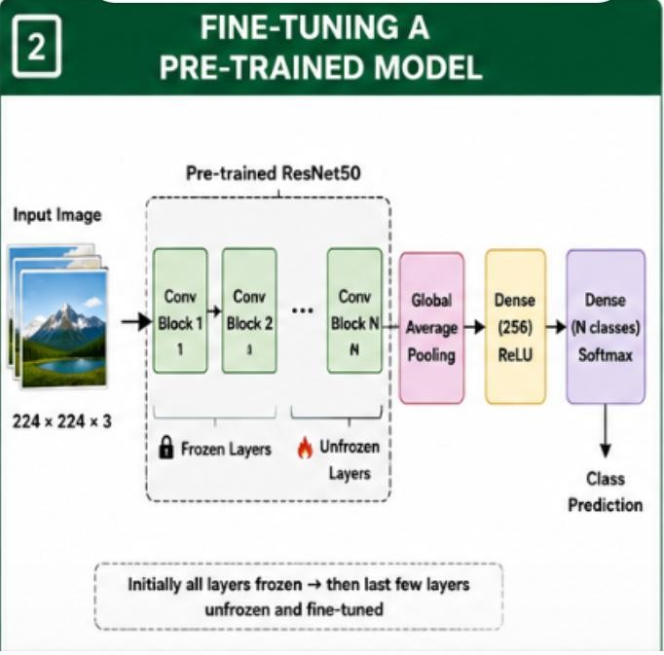 Stage 1 – Feature Extraction
Initially, all ResNet50 layers are frozen.
ResNet50 → Frozen
↓
Custom Classifier
↓
Prediction
Only the newly added classifier is trained.

Stage 2 – Fine-Tuning
The last few layers are unfrozen.
ResNet50

Early Layers → Frozen
Middle Layers → Frozen
Last Layers → Trainable
↓
Custom Classifier
A small learning rate such as 0.0001 is used to avoid destroying previously learned features.

Comparison
Feature | Before Fine-Tuning | After Fine-Tuning
Base layers | Frozen | Some unfrozen
Training time | Lower | Higher
Adaptation | General features | Dataset-specific features
Accuracy | Good | Usually improved
Overfitting risk | Lower | Higher

Effect of Unfreezing Layers
- Few layers unfrozen: Faster and safer.
- More layers unfrozen: Better adaptation but greater overfitting risk.
- All layers unfrozen: Maximum adaptation but requires more data and computation.

Conclusion
Fine-tuning generally improves performance when the new dataset is sufficiently different from the original training data. A small learning rate and gradual unfreezing provide stable training.

QUESTION 3 – FEATURE EXTRACTION-BASED MODEL

Problem
Design and develop a deep learning model using a pre-trained CNN as a feature extractor for a real-world classification problem.

Answer
A pre-trained CNN can be used to extract high-level image features. These extracted features can then be given to a custom machine learning classifier.
For example, ResNet50 can be used for classifying different types of plant diseases. Architecture

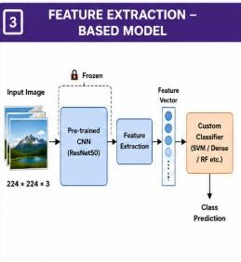

Process
- Collect plant disease images.
- Resize and normalize the images.
- Load a pre-trained ResNet50.
- Remove the original classification layer.
- Freeze the CNN layers.
- Pass images through the CNN.
- Extract deep feature vectors.
- Train a classifier using the extracted features.
- Evaluate the classifier.
Why Feature Extraction?
Early CNN layers learn:
Edges → Textures → Shapes
Deep layers learn more meaningful patterns:
Shapes → Disease Patterns → Disease Features

Advantages
- Requires less training time.
- Uses previously learned visual features.
- Works well with limited datasets.
- Reduces computational requirements.
- Avoids training the complete CNN from scratch.

Evaluation
Suitable metrics include:
- Accuracy
- Precision
- Recall
- F1-score
- Confusion Matrix

Conclusion
Feature extraction using a pre-trained CNN is an effective approach for real-world classification because powerful visual features can be reused without training a complete deep learning model from scratch.

QUESTION 4 – MEDICAL IMAGE CLASSIFICATION

Problem
Design and develop a transfer learning-based model for classifying medical images such as pneumonia, skin disease or brain tumor images. Evaluate accuracy and other performance metrics.

Answer
A transfer learning model can be used to classify chest X-ray images for pneumonia detection.
A pre-trained DenseNet121 can be used because CNNs are effective at extracting visual patterns from medical images.

Architecture
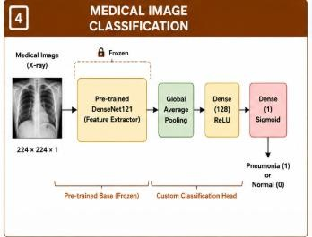

Data Preprocessing
- Resize X-ray images.
- Normalize pixel values.
- Remove corrupted images.
- Split data into training, validation and testing sets.
- Apply augmentation such as rotation and zoom to the training data. Model Training
The pre-trained DenseNet layers are initially frozen.
DenseNet121 → Frozen
↓
Custom Layers → Trainable
↓
Prediction
After initial training, selected deeper layers can be unfrozen for fine-tuning. Output
For binary classification:
Output = Sigmoid

Probability > 0.5 → Pneumonia
Probability ≤ 0.5 → Normal
The threshold can be adjusted depending on the required medical sensitivity.

Evaluation Metrics
Accuracy alone is not sufficient for medical diagnosis.
Important metrics are:

Precision
[
Precision=\frac{TP}{TP+FP}
]

Recall/Sensitivity
[
Recall=\frac{TP}{TP+FN}
]

F1-score
[
F1=2\frac{Precision\times Recall}{Precision+Recall}
]
Also use:
- Confusion Matrix
- Specificity
- ROC-AUC

Importance of Recall
For disease detection, high recall is important because missing an actual disease case can be more serious than generating a false positive.

Conclusion
Transfer learning with DenseNet can provide an efficient medical image classification system. Evaluation should focus not only on accuracy but also on recall, precision, F1-score and other clinically relevant metrics.

QUESTION 5 – RNN FOR TEXT CLASSIFICATION

Problem
Design and develop a Recurrent Neural Network (RNN) model for text classification and explain how sequential information is processed.

Answer
An RNN is designed to process sequential data such as text. It maintains a hidden state that carries information from previous words.
For example, an RNN can classify movie reviews as positive or negative.

Architecture
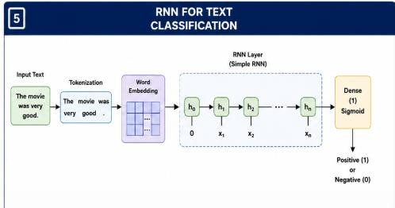

Example
Sentence:

"The movie was very good."
The RNN processes the words sequentially:
The → movie → was → very → good
↓ ↓ ↓ ↓ ↓ h1 h2 h3 h4 h5
Each hidden state depends on the current word and the previous hidden state. RNN Formula
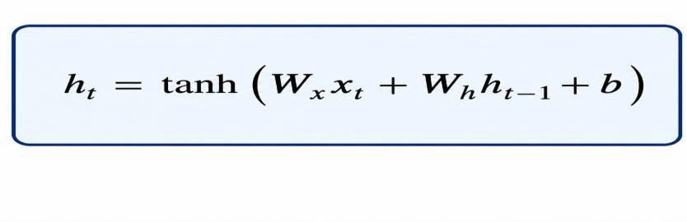 where:
- (x_t) = current input
- (h_{t-1}) = previous hidden state
- (h_t) = current hidden state
- (W_x) = input weight
- (W_h) = recurrent weight
- (b) = bias

Training Steps
- Collect text dataset.
- Clean the text.
- Tokenize sentences.
- Convert words into numerical sequences.
- Apply padding.
- Use word embeddings.
- Pass sequences through the RNN.
- Add a classification layer.
- Train using backpropagation through time.
- Evaluate the model. Example Code
from tensorflow.keras.models import Sequential from tensorflow.keras.layers import Embedding, SimpleRNN, Dense

model = Sequential([
Embedding(10000, 64),
SimpleRNN(64),
Dense(1, activation="sigmoid")
])

model.compile(optimizer="adam",
loss="binary_crossentropy", metrics=["accuracy"])

model.summary() Evaluation Use:
- Accuracy
- Precision
- Recall
- F1-score
- Confusion Matrix

Advantages of RNN
- Handles sequential data.
- Maintains information from previous time steps.
- Useful for text classification.
- Can process variable-length sequences.

Limitation
Traditional RNNs may struggle with long-term dependencies because of the vanishing gradient problem. LSTM or GRU networks can be used when longer contextual information is required.

Conclusion
RNNs are suitable for text classification because they process words sequentially and maintain information from previous words through their hidden states.

Rubrics for Calculation

Criteria | Weightage | Level 4 (Exemplary) | Level 3 (Proficient) | Level 2 (Developing) | Level 1 (Beginning)
Technical Content  Accuracy | 30 | Highly accurate, indepth, and  insightful technical explanation | Technically correct content  with adequate depth and clarity | Basic concepts presented with  limited accuracy and depth | Content contains major technical  errors; concepts poorly understood
Problem  Identification | 25 | Problem rigorously analyzed using  appropriate and advanced methods | Problem clearly defined with a logical  engineering approach | Problem  identified but analysis or  methodology is weak | Problem statement unclear or incorrect; no logical approach
Use of Tools | 20 | Advanced tools, wellanalyzed data, and highly effective visuals | Appropriate tools and data  used effectively with clear visuals | Limited use of tools and basic data  interpretation | Minimal or incorrect use of tools and data; poor visuals
Communication | 15 | Highly engaging, confident, and  audience-focused delivery | Clear, organized, and professional communication | Understandable but lacks clarity, structure, or confidence | Poor organization,  unclear speech, ineffective slides
Professionalism | 10 | Exemplary professionalism, leadership, and ethical awareness | Professional conduct with  effective team collaboration | Basic professionalism;  uneven team participation | Lacks professionalism; minimal  contribution or ethical  awareness

Faculty In-charge | Course Coordinator | Program Director
Signature: | Signature: | Signature:
Date: | Date: | Date:

